1. Name the organisms found in root nodules.

____________________________________________________________________

1. Give any one use of trees around a home.

____________________________________________________________________

1. **In the space below, draw a diagram showing hypogeal germination**
2. Which part of a cow is attacked by a disease detected by using a strip cup?

____________________________________________________________________

1. Which condition leads to goiter?

____________________________________________________________________

1. Give one reason why water is used in the making of ORS.

____________________________________________________________________

1. Why is immunization in Uganda given to children freely?

____________________________________________________________________

**The diagram below, shows a method of making magnets. Use it to answer questions 8 and 9.**

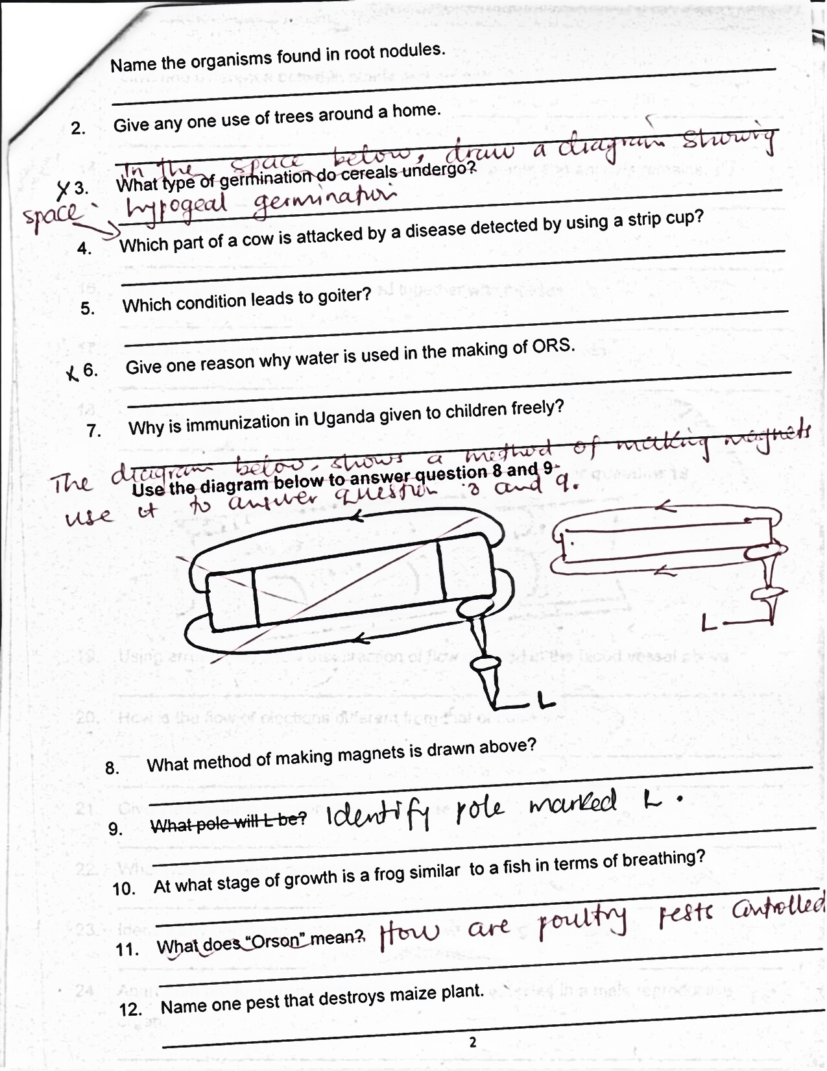

1. What method of making magnets is drawn above?

____________________________________________________________________

1. Identify pole marked L.

____________________________________________________________________

1. At what stage of growth is a frog similar to a fish in terms of breathing?

____________________________________________________________________

1. How are poultry pests controlled?

____________________________________________________________________

1. Name one pest that destroys maize plant.

____________________________________________________________________

1. Give one difference between plants and animals.

____________________________________________________________________

____________________________________________________________________

1. Write the component of soil that is formed from plants and animals remains.

____________________________________________________________________

1. Why is it important to carry out mulching in crop growing?

____________________________________________________________________

1. Give one plant that can be grouped together with mosses.

____________________________________________________________________

1. State any one law that governs the taking of alcohol in Uganda.

____________________________________________________________________

1. Give any one use of paraffin at home.

____________________________________________________________________

**Use the diagram of blood vessel drawn below to answer question 19**

1. Using arrows ( ) show the direction of flow of blood in the blood vessel above.

____________________________________________________________________

1. How is the flow of elections different from that of current?

____________________________________________________________________

____________________________________________________________________

1. Give the digestive function of the pancreas.

____________________________________________________________________

1. What type of change occurs when an electric filament burns?

____________________________________________________________________

1. Identify any one disadvantage of treating water using chemicals.

____________________________________________________________________

1. Apart from producing sperms, give another use of testes in a male reproductive organ.

____________________________________________________________________

1. Mention any one substance that is used in fire extinguishers.

____________________________________________________________________

1. Give any one reason why people use a wheel barrow to carry heavy loads.

____________________________________________________________________

1. Why should motorcyclists wear helmats?

____________________________________________________________________

1. Write any one step used to obtain clean milk from a cow.

____________________________________________________________________

1. State any one way of reducing moisture in a poultry house.

____________________________________________________________________

**The diagram below shows a fruit. Use it to answer questions 30 and 31.**

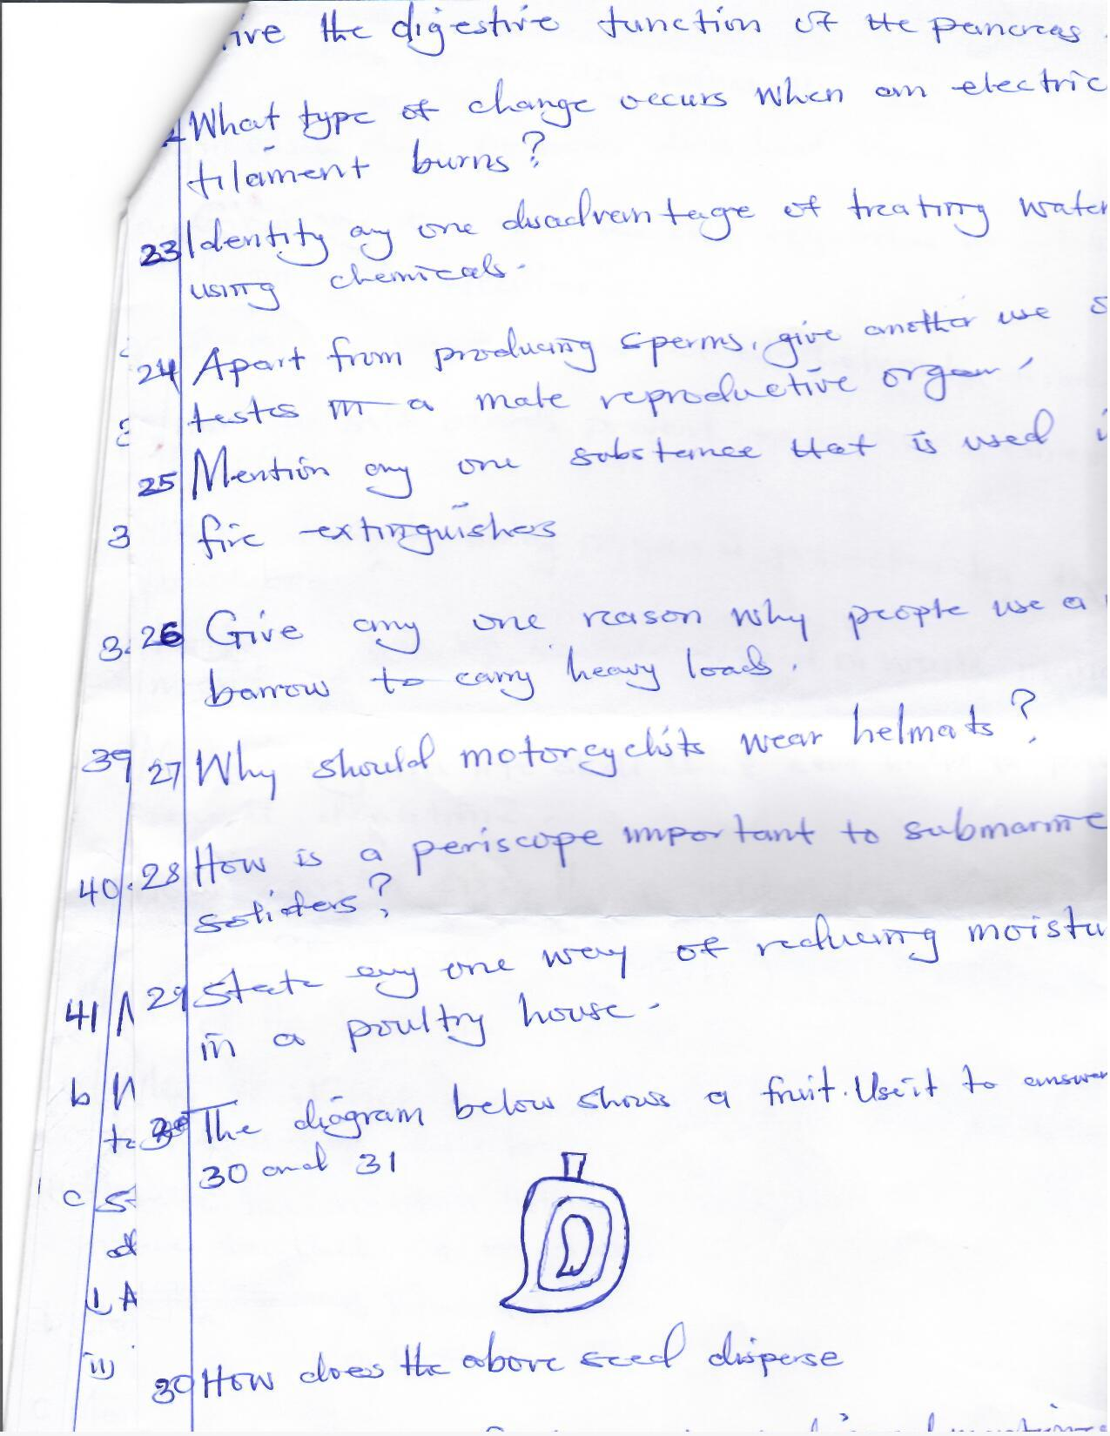

1. How does the above seed disperse?

____________________________________________________________________

1. Give a reason for the mode of dispersal mentioned in number 30 above.

____________________________________________________________________

1. How does overgrazing affect the soil?

____________________________________________________________________

1. Write any one characteristic of energy.

____________________________________________________________________

1. Give any one way the skin regulates body temperature during cold weather.

____________________________________________________________________

1. State any one danger of alcoholism to an individual.

____________________________________________________________________

1. How do soft boards prevent echoes in a cinema hall?

____________________________________________________________________

1. Which delicate body organ is protected by the backbone?

____________________________________________________________________

1. Write any one of the 5Rs as used in waste management.

____________________________________________________________________

1. Mention any one life skill that can help to prevent sexual deviations.

____________________________________________________________________

1. How can a six’s thermometer be reset?

____________________________________________________________________

**SECTION B: 60 MARKS**

1. a) Name the best food for two months old babies.

____________________________________________________________________

b) Why is it not advisable for HIV positive mothers to breast feed their babies?

____________________________________________________________________

c) Under what conditions are mothers not advised to breast feed their babies?

i) __________________________________________________________________

ii) __________________________________________________________________

1. a) Name any one type of latrines.

____________________________________________________________________

b) How far should a pit latrine be from a water source?

____________________________________________________________________

c) Give the function of a screen on a pit latrine.

____________________________________________________________________

d) Why should VIP latrines have spiral walls?

____________________________________________________________________

1. **The diagram below is of a respiratory system, use it to answer the following question 43.**

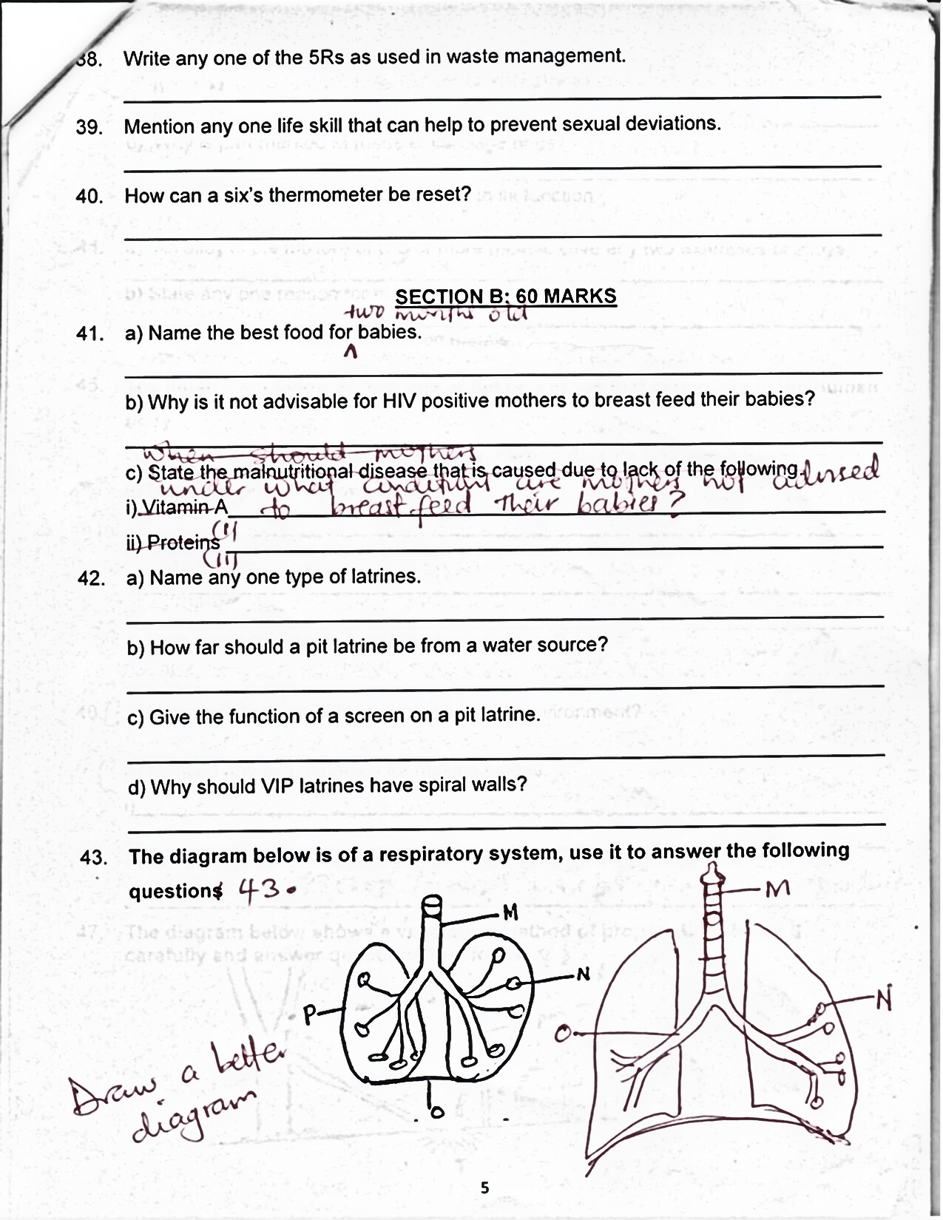

1. Name the parts marked M and O.
2. M_________________________ ii) O_________________________
3. Why is part marked M made of cartilage rings?

_________________________________________________________________

1. Give any one way part N is adapted to its function

_________________________________________________________________

1. a) An alloy is the mixture of two or more metals. Give any two examples of alloys

____________________________________________________________________

b) State any one reason for making alloys.

____________________________________________________________________

c) Mention any one effect of heat on metals.

____________________________________________________________________

1. **The illustration below shows one of the processes that take place in the human body**

**Glucose + Oxygen Energy, carbon dioxide and water vapour**

a) Name the process shown above.

____________________________________________________________________

b) State two ways the above process is important to the human body.

i)___________________________________________________________________

ii)___________________________________________________________________

c) How do plants benefit from the above process?

____________________________________________________________________

1. a) Mention any two materials for making biogas.

____________________________________________________________________

b) How does the use of biogas conserve the environment?

i)___________________________________________________________________

ii)___________________________________________________________________

c) How do crop farmers benefit from biogas production?

____________________________________________________________________

1. **The diagram below shows a vegetative method of propagation. Study it carefully and answer question that follow 47.**

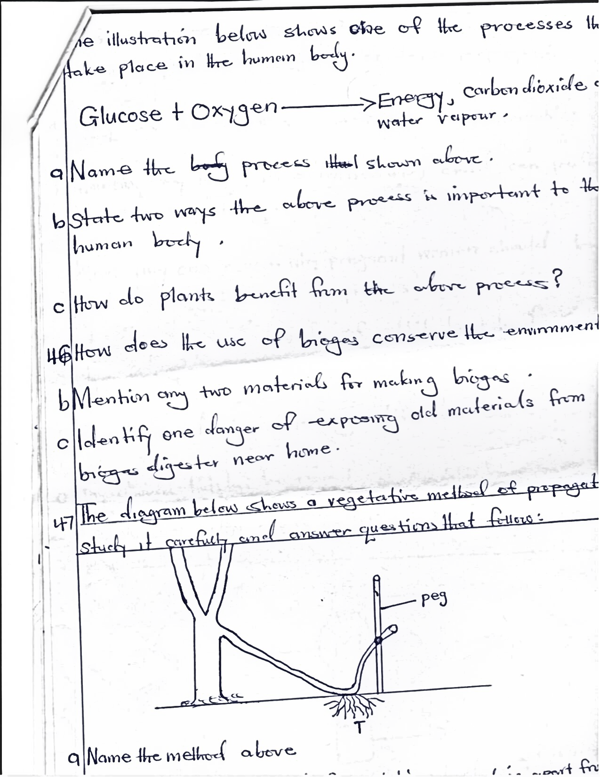

1. Name the method shown above.

_________________________________________________________________

1. Write any one fruit tree propagated by using the above method.

_________________________________________________________________

1. Give any two advantages of vegetative propagation.

i)________________________________________________________________

ii)________________________________________________________________

1. a) Why are the elderly regarded to be vulnerable?

____________________________________________________________________

b) Mention any two PHC activities a P.7 child can perform to help the elderly.

i)___________________________________________________________________

ii)___________________________________________________________________

c) Why are pregnant women fed on much food rich in proteins?

____________________________________________________________________

1. a) Identify any two breeds of rabbits kept by farmers in Uganda.

____________________________________________________________________

b) Give one advantage of rearing rabbits over cattle.

____________________________________________________________________

c) Why should hutches be raised off the ground?

____________________________________________________________________

1. **The diagram below shows an intestinal worm. Use it to answer question that follow 50.**

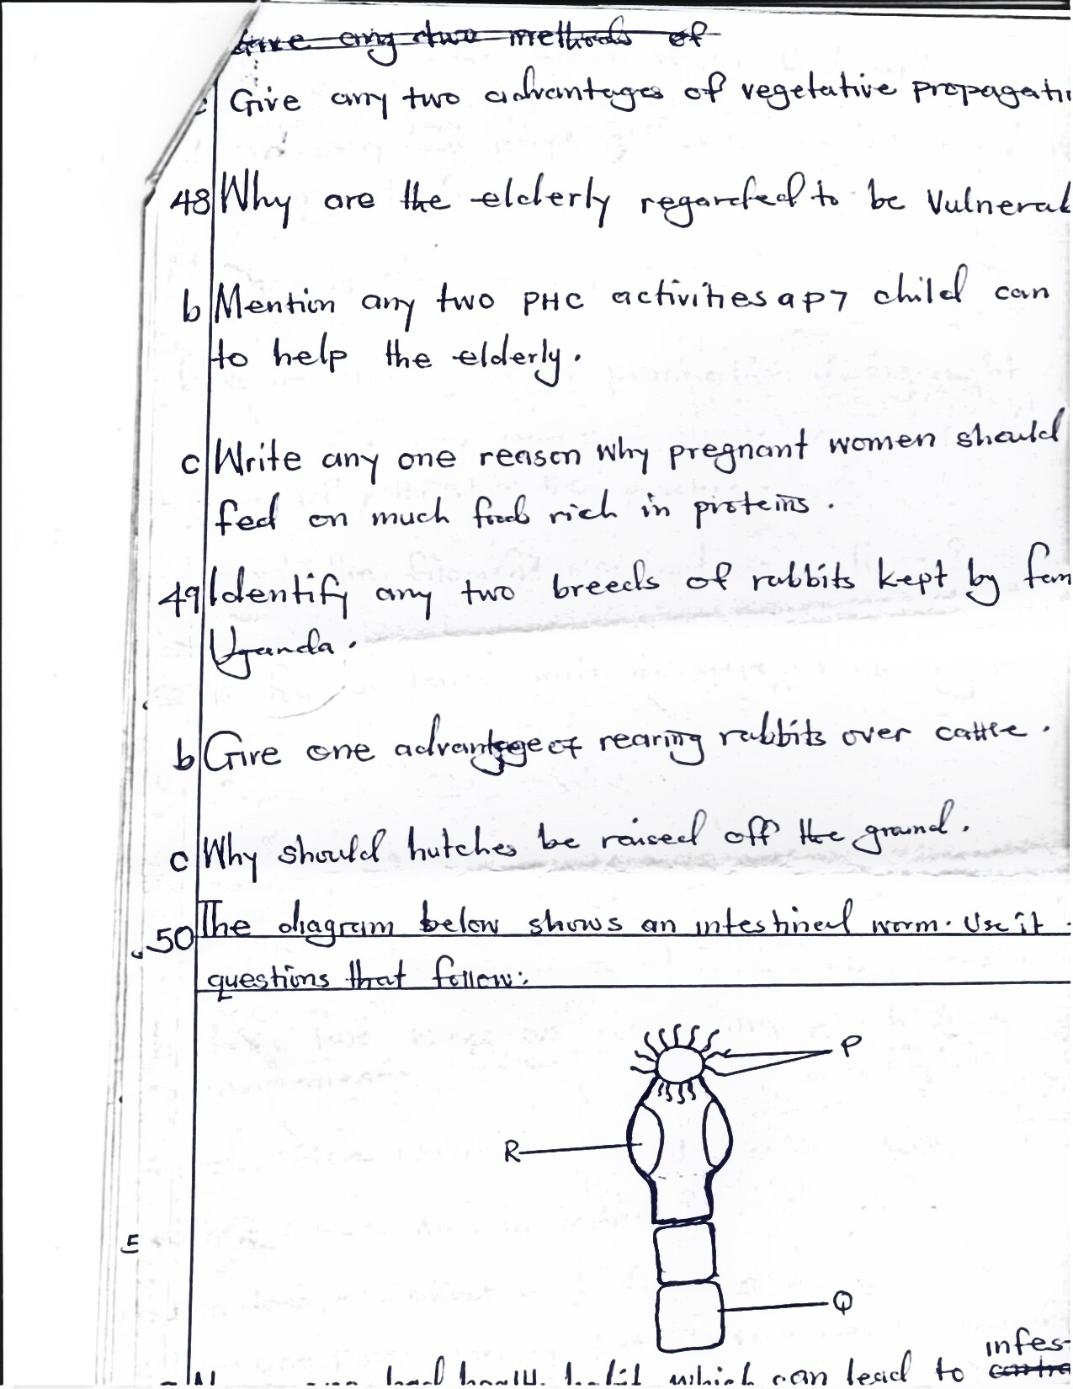

a) Name one bad health habit which can lead to infestation of the above worm.

____________________________________________________________________

b) What does the above worm feed on?

____________________________________________________________________

d) Give any one way of controlling intestinal worms among children.

____________________________________________________________________

1. a) What is cross pollination?

____________________________________________________________________

b) Name one agent of pollination during night.

____________________________________________________________________

c) State one way paw paw plants are adapted to the type of pollination they practice.

____________________________________________________________________

1. How is the filament important on a flower?

____________________________________________________________________

1. **In four sentences write the steps of marking ORS locally**

____________________________________________________________________

____________________________________________________________________

____________________________________________________________________

____________________________________________________________________

____________________________________________________________________

____________________________________________________________________

____________________________________________________________________

____________________________________________________________________

____________________________________________________________________

____________________________________________________________________

1. a) Mention any one non-living component of the environment.

____________________________________________________________________

b) State two ways of conserving plants in the environment.

i)___________________________________________________________________

ii)___________________________________________________________________

c) How do wet lands control floods in the environment?

____________________________________________________________________

1. a) What causes AIDs in babies?

___________________________________________________________________

b) How does AIDS affect the body of a person?

___________________________________________________________________

c) Give one PIASCY message that helps to prevent the spread of AIDS among adolescents.

___________________________________________________________________

d) State any one disease that can be mistaken for AIDs.

___________________________________________________________________

1. **The diagram below shoes a simple electric circuit. Study it and answer questions that follow**

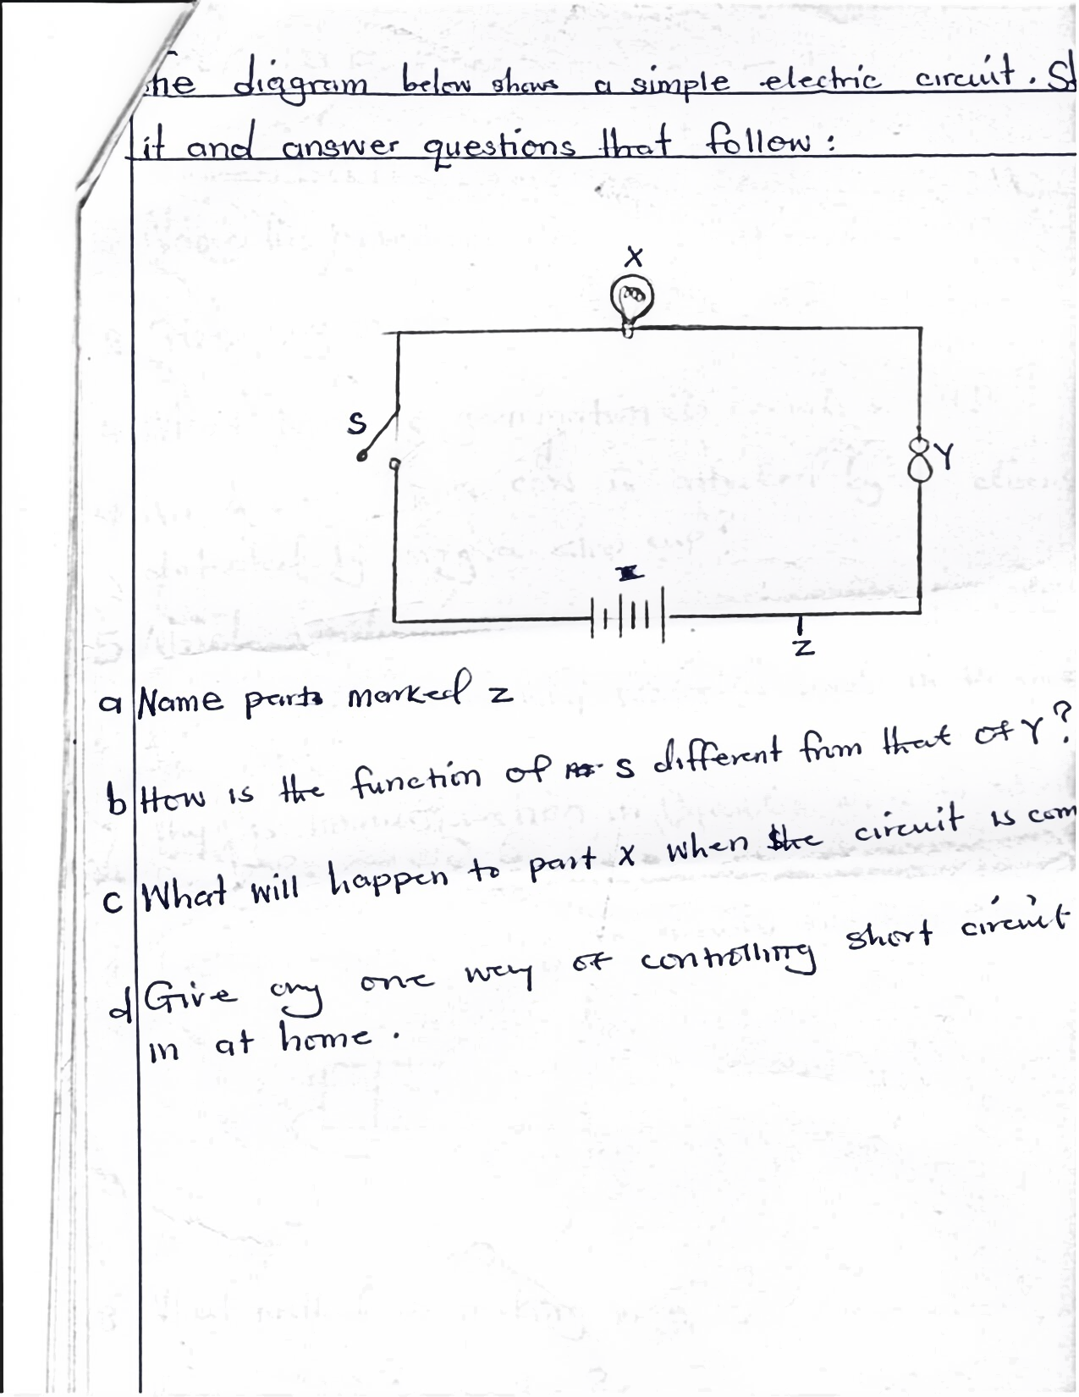

1. Name part marked Z.

_________________________________________________________________

1. How is the function of S different from that of Y?

_________________________________________________________________

1. What will happen to part X when the circuit is completed?

_________________________________________________________________

1. Give any one way of controlling short circuit in a home

_________________________________________________________________

**END**